 | 12.1.9 Editors - Geometry Nodes Editor - Header - Add Menu - Geometry
Table of content
Detailed table of content 1
Add menu - Geometry 2
Bounding Box 2
Convex Hull 3
Delete Geometry 3
Join Geometry 4
Raycast 4
Separate Components 6
Transform 7

Detailed table of content
Detailed table of content
Detailed table of content 1
Add menu - Geometry 2
Bounding Box 2
Inputs 3
Geometry 3
Output 3
Bounding Box 3
Min 3
Max 3
Convex Hull 3
Inputs 3
Geometry 3
Output 3
Convex Hull 3
Delete Geometry 3
Inputs 3
Geometry 3
Selection 3
Invert 4
Output 4
Geometry 4
Join Geometry 4
Inputs 4
Geometry 4
Output 4
Geometry 4
Raycast 4
Inputs 4
Geometry 4
Target Geometry 5
Ray Direction 5
Ray Length 5
Target Attribute 5
Is Hit 5
Hit Position 5
Hit Normal 5
Hit Distance 5
Hit Attribute 5
Properties 5
Mapping 5
Nearest 5
Interpolated 5
Ray Direction 5
Attribute 6
Vector 6
Ray Length 6
Attribute 6
Vector 6
Outputs 6
Geometry 6
Separate Components 6
Inputs 6
Geometry 6
Outputs 6
Mesh 6
Point Cloud 7
Curve 7
Volume 7
Transform 7
Inputs 7
Geometry 7
Translation 7
Rotation 7
Scale 7
Output 7
Geometry 7

Add menu - Geometry
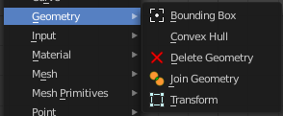
Here you find nodes to modify the geometry.

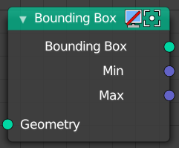
Bounding Box
The Bounding Box geometry node allows you to work with the values of a bounding box.

Inputs

Geometry
Standard geometry input.

Output

Bounding Box
Standard output.

Min
The minimum values of the bounding box.

Max
The maximum values of the bounding box.

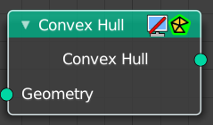
Convex Hull
The node allows you to work with the values of a convex hull of this object.

Inputs

Geometry
Standard geometry input.

Output

Convex Hull
Standard output.

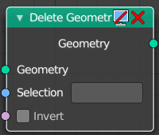
Delete Geometry
Allows to delete geometry.

Inputs

Geometry
Standard geometry input.

Selection
A selection of a geometry.

Invert
Invert the selection of the geometry.

Output

Geometry
Standard geometry output.

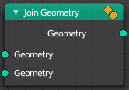
Join Geometry
The Join Geometry enables you to merge separately generated pieces of geometry into a single one. In case that the inputted pieces contain different types of geometry, the output will contain multiple types of geometry.

Inputs

Geometry
Standard geometry input.

Output

Geometry
Standard geometry output.

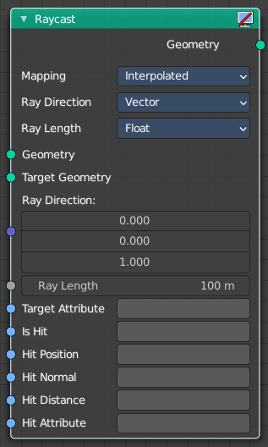
Raycast
Casts rays from one geometry to another. When the ray hits something within its maximum ray length, then you can retreive several different data sets.
Hit Position, Hit Normal and Hit Distance are the properties of the target mesh at the intersection point. Additionally a Target Attribute can be specified that is interpolated at the hit point and the result stored in Hit Attribute.

Inputs

Geometry
Rays are created at the geometry points.

Target Geometry
Geometry that rays are tested against.

Ray Direction
Direction of each ray from the starting position.

Ray Length
Maximum distance a ray can travel before being considered „no hit“.

Target Attribute
An optional attribute of the Target Geometry that will be interpolated at the hit points. The resulting values are stored in the output attribute named by Hit Attribute.

Is Hit
Boolean output attribute that is true for each ray which has hit the Target Geometry.

Hit Position
Output attribute storing the intersection point with the target mesh.

Hit Normal
Output attribute storing the surface normal vector at the hit location.

Hit Distance
Output attribute storing distance from the ray origin to the hit point.

Hit Attribute
Output Attribute storing interpolated values of the Target Attribute at the hit positions.

Properties

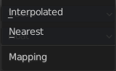
Mapping
How the attributes of the target mesh are mapped to the attribute values on the result geometry.

Nearest
uses the atribute from the nearest geometry.

Interpolated
uses the attribute from the corners of the hit face.

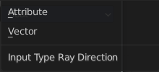
Ray Direction

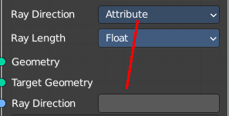
Attribute
Use an attribute instead of a vector for the ray direction.

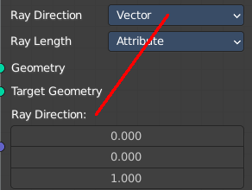
Vector
Use a vector for the ray direction.

Ray Length

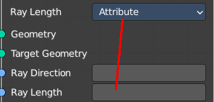
Attribute
Use an attribute instead of a float value for the ray length.

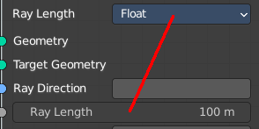
Vector
Use a float value for the ray length.

Outputs

Geometry
The geometry that contains output attributes for each ray.

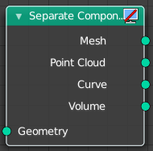
Separate Components
Splits a geometry into its components.

Inputs

Geometry
Geometry input.

Outputs

Mesh
Mesh component of the input geometry.

Point Cloud
Point cloud component of the input geometry.

Curve
Curve component of the input geometry.

Volume
Volume component of the input geometry.
In case that the input contains multiple volume instances, only the first volume component will be calculated.

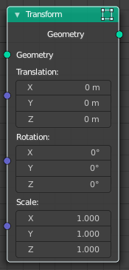
Transform
Move, rotate or scale the geometry. The transformation is applied to the entire geometry, and not per element. For example, you can not rotate individual point cloud points with this node.

Inputs

Geometry
Standard geometry input.

Translation
Translates the geometry in local space of the modified object.

Rotation
Euler rotation in local space.

Scale
Scale to transform the geometries in local space.

Output

Geometry
Standard geometry output.

